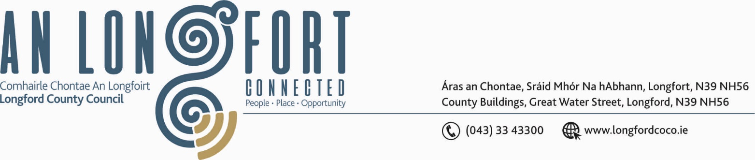

BALLYMAHON MUNICIPAL DISTRICT

25th September 2018.

To: Each Member of Ballymahon Municipal District.

Dear Member,

You are requested to attend Meeting of Ballymahon Municipal District to be held in Ballymahon Community Library on Monday, 1st October 2018 at 4.30 p.m. to transact business, as set out on the Agenda hereunder.

Yours sincerely,
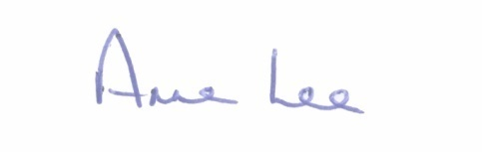

_______________
Anne Lee,
Meetings Administrator.

AGENDA

Prayer before meeting.

1. Confirmation of Minutes of the following Meetings of Ballymahon Municipal District -

- Municipal District Committee Meeting held on the 26th July 2018
- Municipal District Meeting held on the 26th July 2018.
- copies enclosed.

2. Matters arising from Minutes.

3. Management Report - enclosed.

4. Consideration of the Taking in Charge of Corncrake Meadows, Abbeyshrule – report enclosed.

5. Consideration of Adoption of Part 8 Report (Planning and Development Act 2000 (as amended) and Planning and Development Regulations 2001) (as amended) in respect of proposal to carry out a development referred to as – construction of a footbridge over the River Inny at Clooneen and Newcastle, Ballymahon, Co. Longford - details attached.

6. Consideration of applications for funding under the 2018 Community Grant Support Scheme.

7. Notices of Motions submitted by Councillors, as listed hereunder –

Councillor Paul Ross

"That all the houses in Foxhall Cresent, Legan be retrofitted with new energy efficient windows."

"That Longford County Council put a policy in place to maintain the roundabouts and grass verges on the Edgeworthstown bypass."

"That Longford County Council conduct a review of the traffic lights at Pound Street, Edgeworthstown with a view to removing them and replacing with a more suitable junction layout."

Councillor Pat O’Toole.

“In light of the requests to upgrade the Ballymahon Town Sewerage System,
I call on Longford County Council to extend the system to include the following townlands - Terlicken, Moigh, Cartronbouy and Moneyfad.

8. Correspondence - enclosed.

- Correspondence dated 7th August 2018 received from the Department of Employment Affairs and Social Protection regarding Community Welfare Services in Lanesboro.
- Correspondence dated 14th August 2018 received from Irish Water regarding upgrade of sewerage treatment and the wastewater plant in Ballymahon.
- Correspondence received from the Department of Business, Enterprise and Innovation regarding review of the Casual Trading Act 1995 and the Occasional Trading Act 1979.

::::::::::::::::::::::::::

